EXPT NO:4 | TRANSFORM DATA TO SUIT BI REPORTING REQUIREMENTS AND  DESIGN A DASHBOARD WITH KEY PERFORMANCE INDICATORS (KPIs ) USING TABLEAU AND POWERBI
DATE: 24.07.2026

PRE-LAB QUESTIONS (PROVIDE BRIEF ANSWERS TO THE FOLLOWING QUESTIONS)

- What is the role of data transformation in BI reporting?

Data transformation converts raw COVID-19 data into a clean and usable format for analysis. In our exercise, date fields were converted to proper date formats, missing values were handled, and calculated fields such as Case Fatality Rate and Vaccination Coverage were created. This helps produce accurate reports and meaningful visualizations.

- What are the common data cleaning techniques in Tableau and Power BI?

Common techniques include handling NULL or missing values, removing duplicates, correcting data types, filtering unwanted records, and standardizing data formats. In our exercise, we checked for NULL values, converted the date column to the correct date format, and used cleaned fields such as New Cases Clean for analysis.

- How do Tableau and Power BI handle data aggregation?

Both Tableau and Power BI automatically aggregate numerical data using functions such as SUM, AVG, MIN, and MAX. In our exercise, data was aggregated by continent, country, and month, using measures such as SUM(new_cases), AVG(positivity_rate), and MAX(total_deaths).

- What are KPIs, and why are they important in a dashboard?

KPIs (Key Performance Indicators) are important metrics used to quickly understand the overall performance or status of the data. In our COVID-19 dashboard, KPIs included Total Confirmed Cases, Total Deaths, Case Fatality Rate, Vaccination Coverage (%), and Daily Case Growth Rate. They provide high-level insights and help users make quick comparisons and decisions.

- What are the different types of charts available in Tableau and Power BI for visualization?

Tableau and Power BI provide various charts, including bar charts, line charts, pie charts, area charts, scatter plots, maps, and KPI cards. In our exercise, line charts were used for daily cases and deaths, bar charts for country-wise vaccination progress, maps for regional case distribution, and KPI cards for high-level COVID-19 statistics.

IN-LAB EXERCISE:
OBJECTIVE:
To transform COVID-19 data into a structured format suitable for Business Intelligence (BI) reporting and design interactive dashboards with Key Performance Indicators (KPIs) using Tableau and Power BI.

PROCEDURE:
- Data Collection:
  - Import the COVID-19 dataset from inbuilt sources like Our World in Data or CSV files containing country-level COVID statistics (e.g., new cases, deaths, vaccinations).
  - Datasets may include fields such as date, location, new_cases, total_cases, new_deaths, total_deaths, people_vaccinated, etc.
- Data Cleaning and Transformation:
  - Convert columns like date to proper date formats.
  - Handle missing or null values in new_cases, total_cases, etc.
  - Create calculated fields (e.g., daily case growth rate, case fatality rate, vaccination percentage).
- Data Aggregation:
  - Aggregate data by continent, country, or month.
  - Use measures like SUM(new_cases), AVG(positivity_rate), MAX(total_deaths).
- Designing KPIs:
  - Identify KPIs such as:
    - Total Confirmed Cases
    - Total Deaths
    - Case Fatality Rate
    - Vaccination Coverage (%)
    - Daily Case Growth Rate
  - Use DAX (Power BI) or Calculated Fields (Tableau) to compute and visualize these KPIs.
- Dashboard Development:
  - Build visualizations such as:
    - Line charts for daily new cases and deaths
    - Bar charts for country-wise vaccination progress

    - Maps to show regional case distribution
    - KPI cards for high-level insights
  - Use filters (e.g., by continent, country) and slicers (e.g., by date range) for interactivity.
- Publishing and Sharing:
  - Publish the dashboard using Tableau Public/Server or Power BI Service.
  - Share the dashboards with stakeholders through public or organizational portals.
Experiment Dataset:
COVID-19 Global Dataset Fields Used:
  - Date – Date of the report
  - Location – Country or region
  - New Cases – Daily reported cases
  - New Deaths – Daily reported deaths
  - People Vaccinated – Cumulative vaccinated count
  - Total Cases – Cumulative confirmed cases
  - Total Deaths – Cumulative deaths
  - Population – Total population of the country

Tableau:

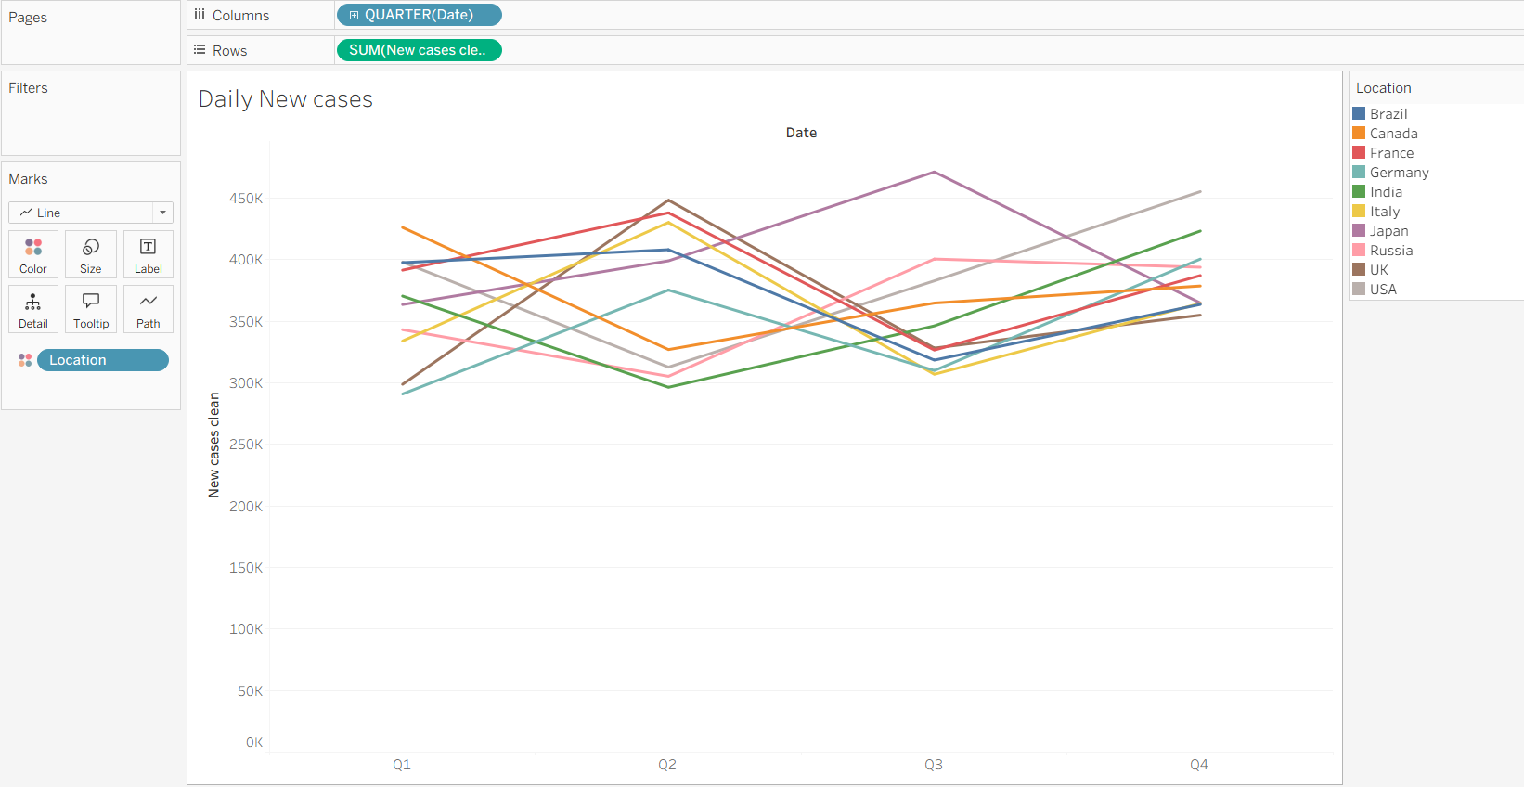

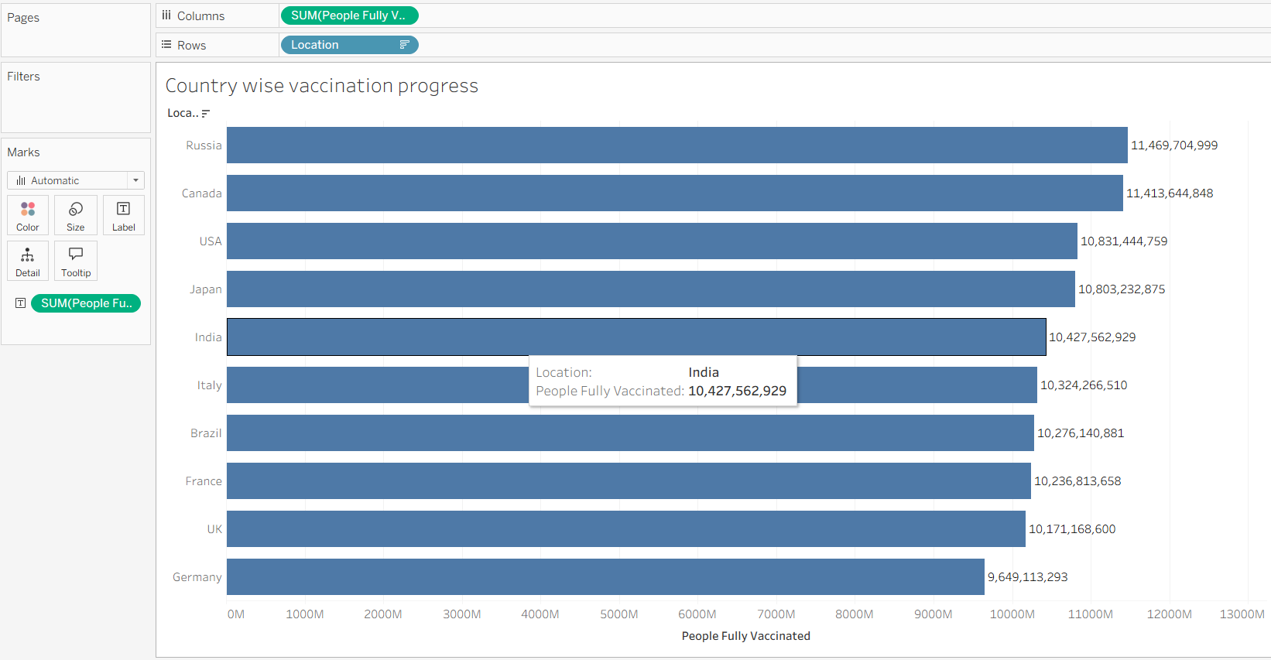

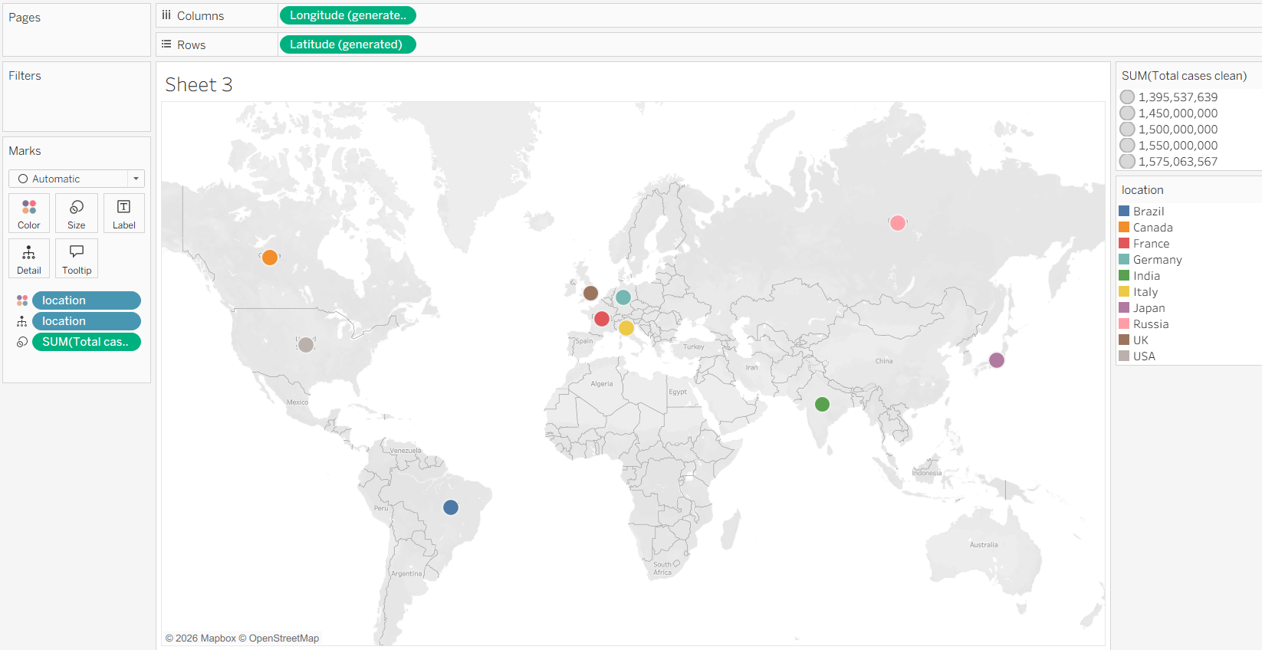

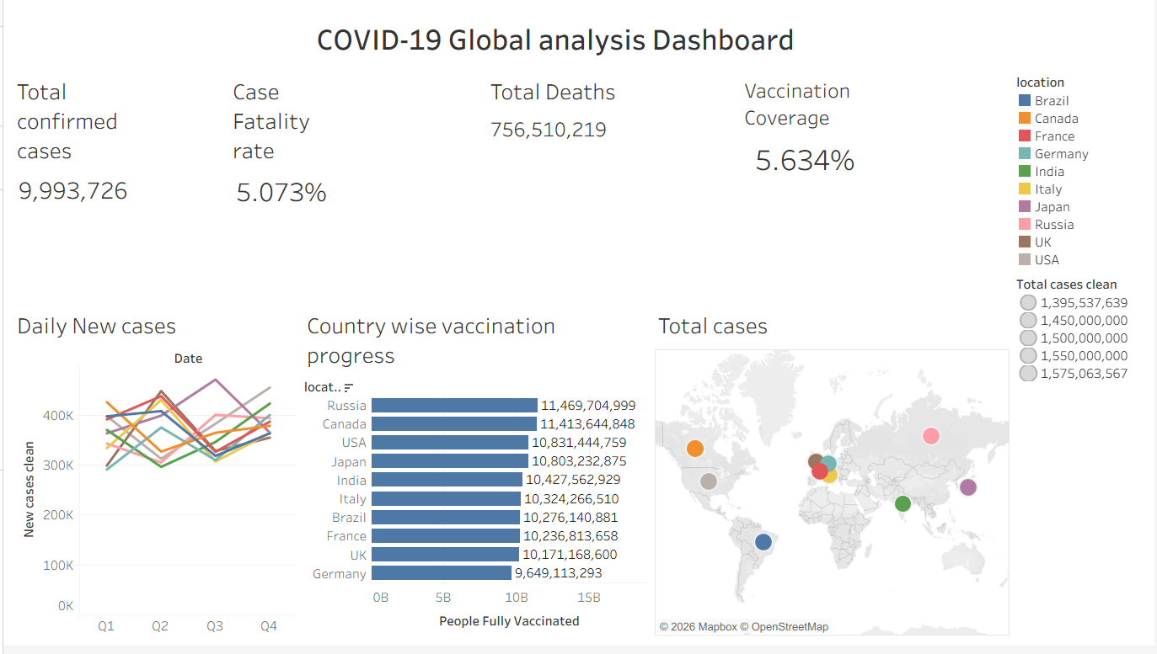

PowerBI:

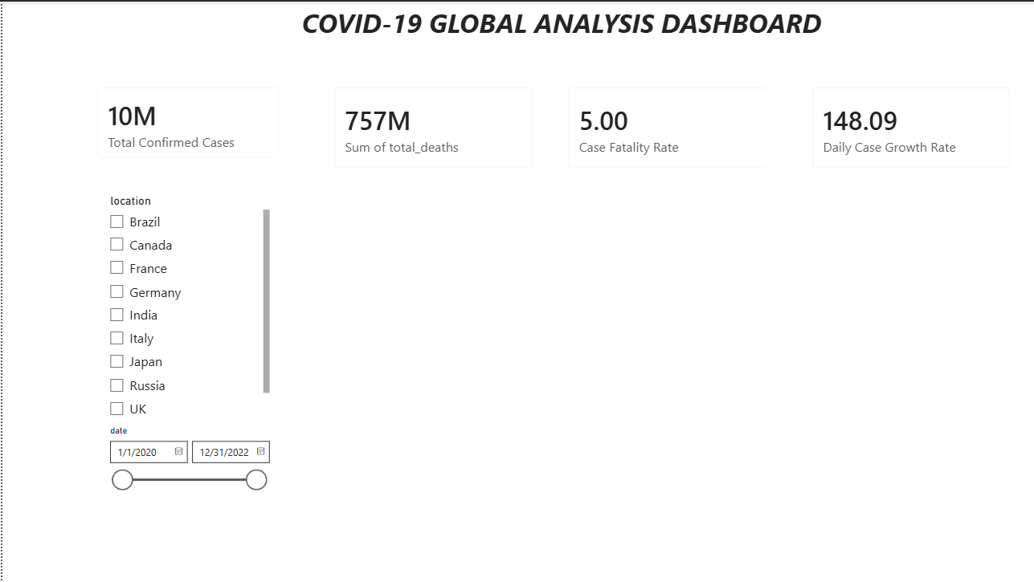

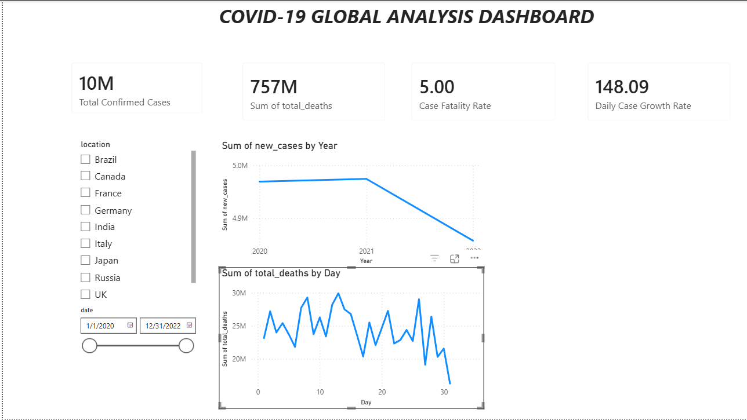

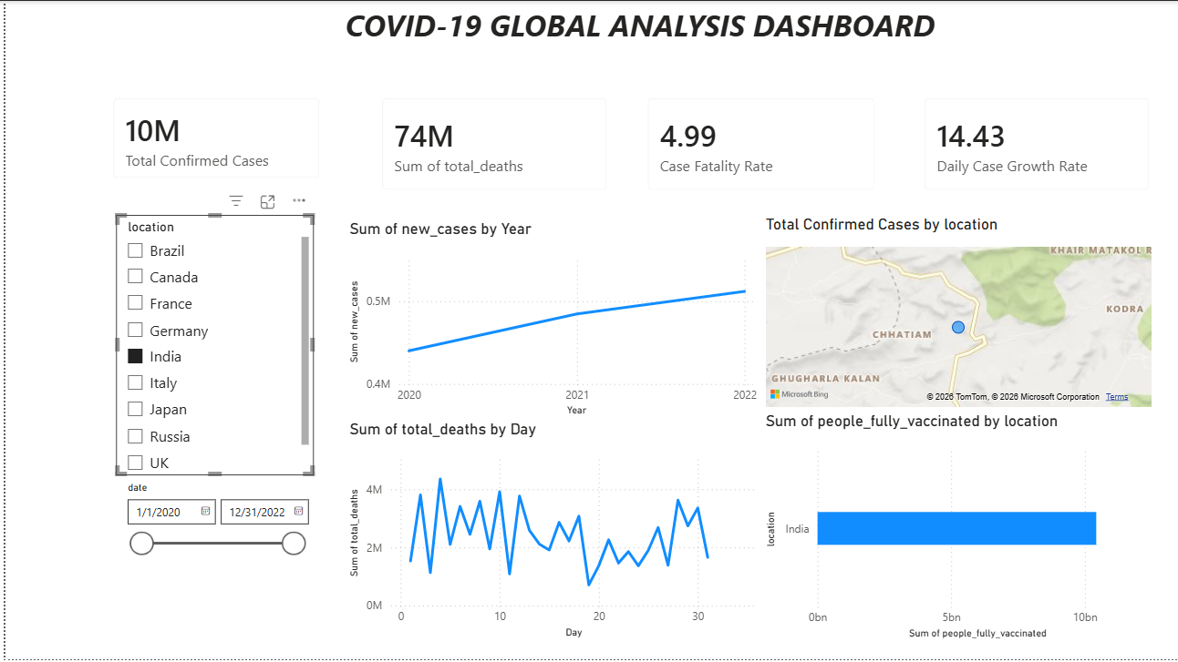

POST-LAB QUESTIONS (PROVIDE BRIEF ANSWERS TO THE FOLLOWING QUESTIONS)
- How did data transformation improve the quality of insights in your COVID-19 dashboard?
Data transformation converted raw COVID-19 data into a clean and structured format for analysis. Converting dates, handling missing values, and creating calculated fields such as Case Fatality Rate and Vaccination Coverage helped produce more accurate and meaningful insights.

- What challenges did you encounter during the data cleaning process, and how did you resolve them?

The main challenges were identifying NULL values, handling missing data, and ensuring that fields such as date were in the correct format. These issues were resolved by checking for NULL values, using cleaned fields such as New Cases Clean, and converting columns to the appropriate data types.

- Which KPI provided the most valuable insight, and why?

Vaccination Coverage (%) provided the most valuable insight because it helped compare vaccination progress across different countries or regions. It also helped understand the relationship between vaccination levels and the overall impact of COVID-19.

- How does interactivity in dashboards improve user experience?

Interactive features such as filters, country selection, continent selection, and date-range filters allow users to explore the data based on their specific needs. This makes the dashboard easier to use and helps users quickly identify trends and compare different regions.

- What steps would you take to further enhance the dashboard’s effectiveness?

I would improve the dashboard by adding more interactive filters, tooltips, trend indicators, and additional KPIs. I would also improve the visual layout, use consistent formatting, and add comparisons between cases, deaths, and vaccination rates to provide deeper insights.

RESULT:

The COVID-19 dataset was successfully cleaned, aggregated, and transformed for visual analysis using Tableau and Power BI. Missing values, data type mismatches, and inconsistencies were addressed. KPIs such as vaccination rate and daily case growth offered valuable insights into the pandemic trends across countries and timeframes. The resulting interactive dashboards allowed for effective public health monitoring and communication.

ASSESSMENT

Description | Max Marks | Marks Awarded
Pre Lab Exercise | 5
In Lab Exercise | 10
Post Lab Exercise | 5
Viva | 10
Total | 30
Faculty Signature

